LED BEAM MOVING HEAD

USER MANUAL

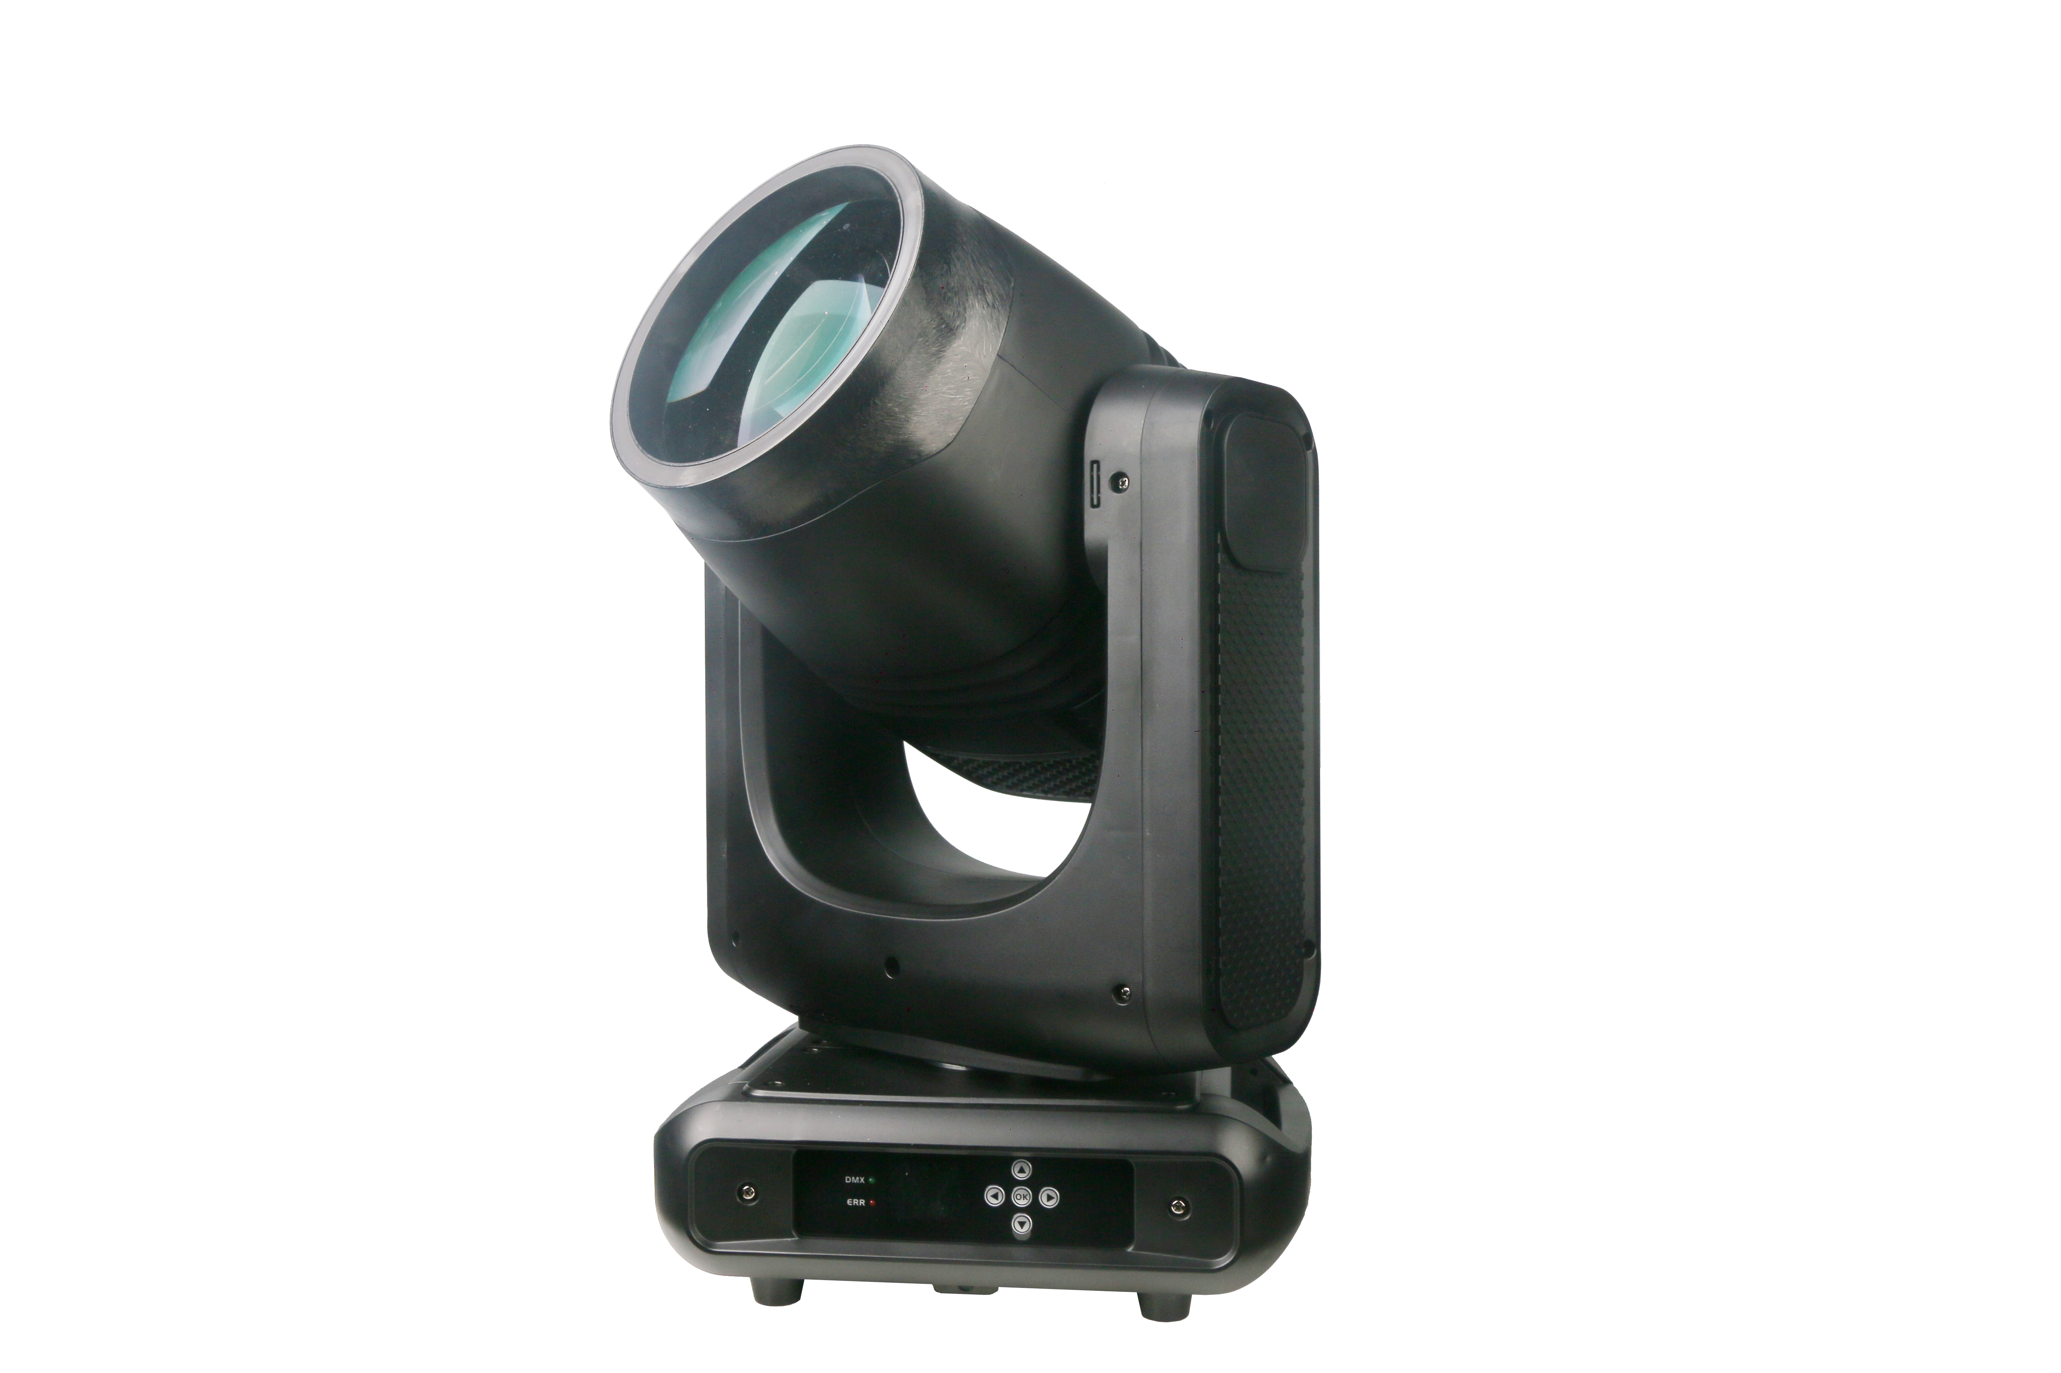

Please read and keep this manual carefully for further use!

Thank you for buying our professional Beam moving head.
This user manual includes important information for installation and operation, so please read this user manual carefully before installation and operation, and keep this user manual well for further use.
In order to install , operate, and maintain the lighting safety and correctly. We suggest that the installation and operation should be done by the verified technician and follow the instruction strictly.
Spare part includes:
Name | QTY | Unit
Fixture | 1 | PC
User manual | 1 | PC
Power cable | 1 | PC
Bracket | 2 | PCS
DMX signal cable | 1 | PC
Safety rope | 1 | PC

Please check carefully that there is no damage caused by transportation. Should there be any, consult your local dealer.
Cautions
Before delivery, this device has passed strict inspection, Please follow the user manual strictly for operation, if this fixture is damaged by improper operation and mistake, the fixture will be out of warranty, and manufacture or dealer won’t be responsible for it. In case of any technology change in this manual,we won’t advise in further .



CAUTION!

Keep this device away from rain and moisture!

Unplug mains lead before opening the housing!

Warning!

Silkscreen symbol on light
Damages caused by the disregard of this user manual are not subject to warranty. The dealer will not accept liability for any resulting defects or problems.

Installation
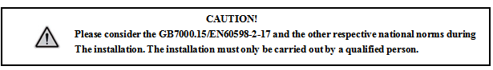

► This fixture is not suitable for direct installation on combustible material surface, please keep the fixture surface at least 0.5m from any combustible material.

► If you use the quick lock cam in hanging up the fixture, please make sure the quick lock fasteners turned in the quick lock holes correctly.
►The applicable temperature for the fixture is between -25°C to 45°C. Do not use the lighting under or above this temperature range.
►The truss for hanging the fixture should be able to hold 10 times weight of this fixture and no deformation after 1 hour hang.
►Please don’t stand under the fixture when install, uninstall, move or repair the fixture.
►Please ensure the light is connected correctly and invite professional technician to check and confirm the electrical data before installation.
►Please invite professional technician to check the fixture and installation each year.
Rigging：

Clamp
Bracket
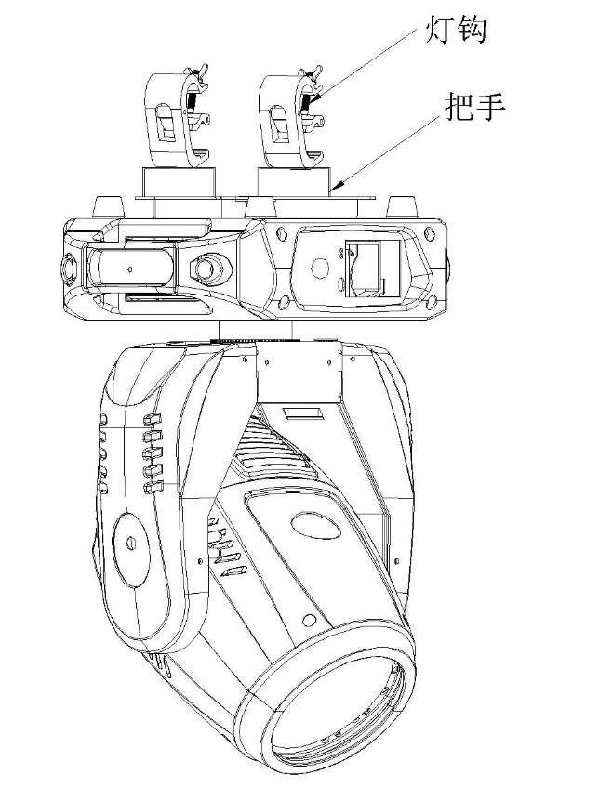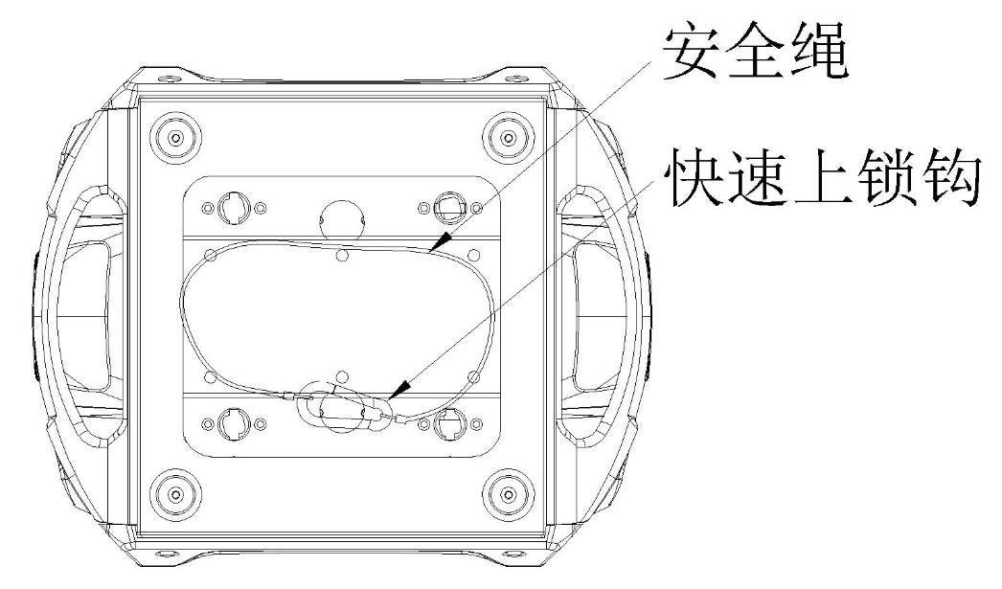
Safety rope
Quick lock

Insert the quick-lock fasteners of the first holder into the respective holes on the bottom of the device.Tighten the quick-lock fasteners fully clockwise.
Fix the clamp on truss or other fixture bracket.
Pull the safety rope through the holes on the bottom of the base and fasten it on the truss or other fixing point.
Note:This step is quite important to ensure that fixture will not drop down for the clamp damage.

Product specification

1. Voltage：100-240V，50/60HZ；
2. Power Consumption：200W；
3. Lamp:200W LED
4.Fuse:6.3A/250V，￠5*20
5.DMX Channel: 19CH
6.Operation mode: master-slave/DMX/Auto
7. Focus: Yes
8. Fixed gobo: 12 gobos+open+ 5 glass gobos
9. Electronic strobe: 25Hz
10. Color: 14 colors+open
11. Prism 1: 8-facet
12. Prism 2: 8+16+32-facet
13. Pan: 540°
14. Tilt: 270°
15.Frost: Yes
16.Six-color effect: Yes
17. RDM: Yes
18. Standard beam angle: 2°
19. Display: LED LCD screen

Display and operation

Touch button | Function
Up | Option, Edit
Down | Option, Edit
Left | Backtrack, Edit
Right | Backtrack, Edit
OK | Enter to edit , confirm

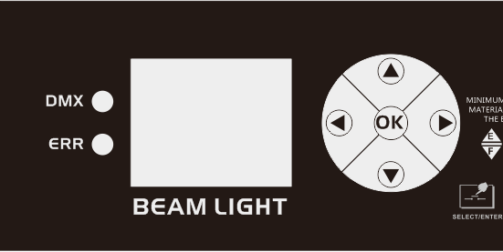

Setting:

Option | Description
Operating mode | DMX | slave status: receiving DMX signals from the console or master
Operating mode | AUTO 1 | master state: auto and send DMX signal to the slave
Operating mode | AUTO 2 | master state: auto and send DMX signal to the slave
Operating mode | Random | master state: auto and send DMX signal to the slave
Operating mode | Sound | master state: auto and send DMX signal to the slave
DMX address | 1~512 | Press the "OK" key to enter the editing state.
Channel mode | 19 CH | Standard 19-channel mode
X reverse | off
X reverse | on
Y reverse | off
Y reverse | on
XY exchange | off
XY exchange | on | Exchange the channels of the XY axis (including fine-tuning)
XY encoder | on | Use the encoder (optocoupler) to judge the out-of-step and automatically correct the position
XY encoder | off | Does not use encoder (optocoupler) to correct position
DMX signal | hold | running in the original state
DMX signal | clear | the motor back to position, stop running
Lamp on | off | Reset directly after power on, the bulb will not on
Lamp on | on | lamp on after power on, the bulb will light up automatically, and it will be reset only after the bulb is on
Color wheel linear change | on | The color wheel changes linearly
Color wheel linear change | off | Non-linear change of color wheel, half color change
Default settings |  | Press the "OK" button to see the confirmation dialog box, press the "OK" button again to restore the default settings

19 DMX channel
19CH | Function | Value | Details
CH1 | Color wheel | 000-004  005 -009  010 - 014  015 - 019  020 - 024  025 - 029  030 - 034  035 - 039  040 - 044  045 - 049  050 - 054  055 - 059  060 - 064  065 - 069  070 - 074  075 - 079  080 - 084  085 - 089  090 - 094  095 - 099  100 -104  105 -109  110 -114  115 -119  120 -124  125 -129  130 -134  135 -139  140 -144  145 -149  150 - 200  201 - 255 | White  White+Color 1  Color 1  Color 1+color 2  Color 2  Color 2+color 3  Color 3  Color 3+color 4  Color 4  Color 4+color 5  Color 5  Color 5+color 6  Color 6  Color 6+color 7  Color 7  Color 7+color 8  Color 8  Color 8+color 9  Color 9  Color 9+color 10  Color 10  Color 10+color 11  Color 11  Color 11+color 12  Color 12  Color 12+color 13  Color 13  Color 12+color 13  Color 14  Color 14+white light  Reverse flow (from fast to slow)  Forward flow (from slow to fast)
CH2 | dimmer | 0-255 | dimmer 0-100%
CH3 | strobe | 000-003  004-103  104-107  108-207  208-212  213-251  252-255 | Shutter closed  Strobe from slow to fast  Open the shutter → (controlled by the dimming channel)  Pulse strobe from slow to fast  Open the shutter → (controlled by the dimming channel)  Random strobe from slow to fast  Open the shutter → (controlled by the dimming channel)

CH4 | gobo wheel | 000 - 004  005 - 009  010 - 014  015 - 019  020 - 024  025 - 029  030 - 034  035 - 039  040 - 044  045 - 049  050 - 054  055 - 059  060 - 064  065 - 069  070 - 074  075 - 079  080 - 084  085 - 089  090 - 094  095 - 099  100 - 104  105 - 109  110 - 114  115 - 119  120 - 124  125 - 129  130 - 134  135 - 139  140 - 144  145 - 149  150 - 154  155 - 159  160 - 164  165 - 169  170 - 174  175 - 215  216 - 255 | gobo 1  gobo 2  gobo 3  gobo 4  gobo 5  gobo 6  gobo 7  gobo 8  gobo 9  gobo 10  gobo 11  gobo 12  gobo 13  gobo 14  gobo 15  gobo 16  gobo 17  gobo 18  gobo 2 shake slow to fast  gobo 3 shake slow to fast  gobo 4 shake slow to fast  gobo 5 shake slow to fast  gobo 6 shake slow to fast  gobo 7 shake slow to fast  gobo 8 shake slow to fast  gobo 9 shake slow to fast  gobo 10 shake slow to fast  gobo 11 shake slow to fast  gobo 12 shake slow to fast  gobo 13 shake slow to fast  gobo 14 shake slow to fast  gobo 15 shake slow to fast  gobo 16 shake slow to fast  gobo 17 shake slow to fast  gobo 18 shake slow to fast  Reverse flow (from fast to slow)  Forward flow (from slow to fast)
CH5 | Prism 1 | 000-127  128-255 | no effect  prism 1
CH6 | prism rotation | 000-127  128-190  191-192  193-255 | prism 1 adjust angle  Reverse rotation fast to slow  stop  Forward rotation slow to fast
CH7 | Prism 2 | 000-127  128-255 | no effect  prism 2
CH8 | frost and six color effect | 000-127  128-191  192-255 | no function  frost  Six-color effect
CH9 | focus | 0-255 | focus 0-100%
CH10 | focus fine | 0-255 | focus fine
CH11 | pan | 0-255 | 0-540 degree
CH12 | pan fine | 0-255 | 0-1.2 degree
CH13 | tilt | 0-255 | 0-270 degree
CH14 | tilt fine | 0-255 | 0-1.2 degree
CH15 | XY speed | 0-255 | speed fast to slow
CH16 | Reset | 000-025  026-076  077-127  128-255 | no function  small motors reset  Pan/Tilt motors reset  all motors reset
CH17 | LED strobe | 0-255 | Strobe from slow to fast
CH18 | LED effect | 0-255
CH19 | LED speed | 0-255 | Speed from slow to fast

Gobo wheel Color wheel
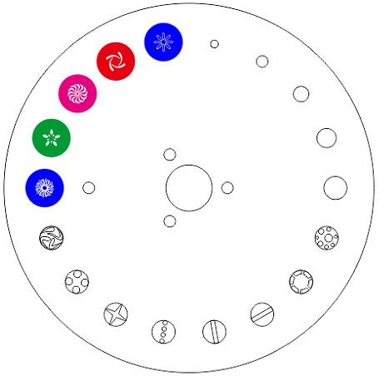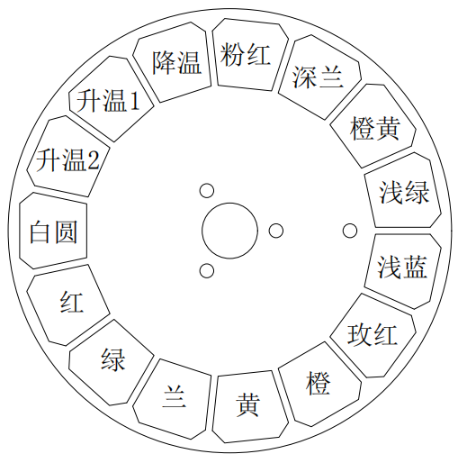

Six-color effect / Frost

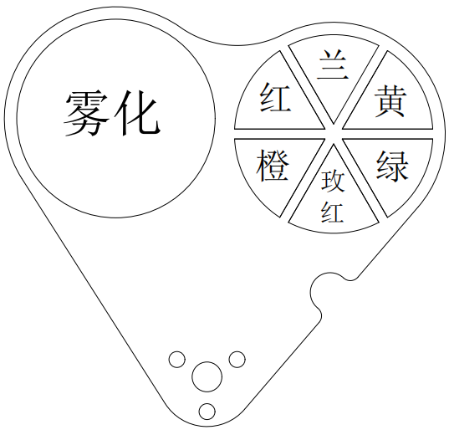

DMX-512 connection

Connect the provided XLR cable to the male 3-pin XLR output of your controller and the other side to the female 3-pin XLR input of the light.then connect the DMX signal to the first fixture to the 2nd fixture, after all fixtures are connected,

The signal cable should be two - core with screened cable with XLR input and output connectors. Please refer to the diagram below

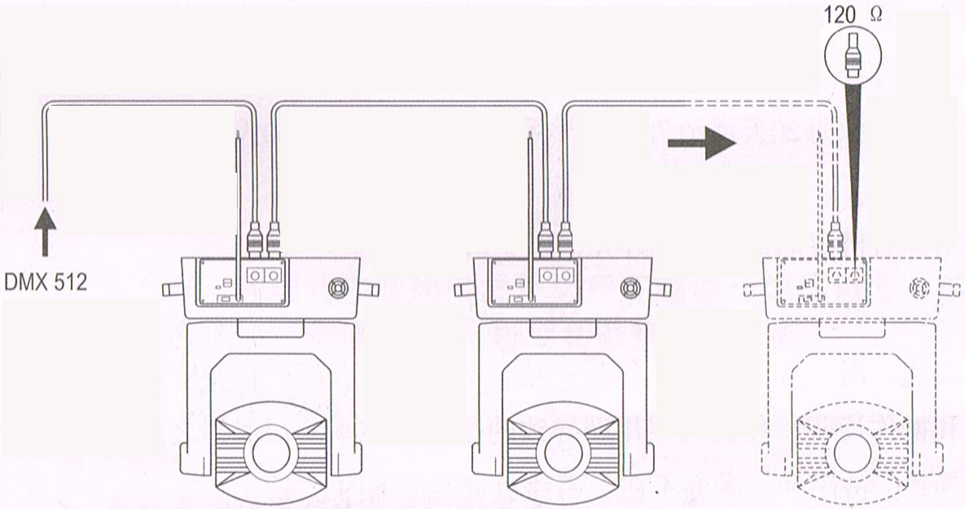

DMX terminator connection
If there are many lines or lights, it is recommended to use a DMX terminator to prevent DMX signal corruption, the DMX terminator is an simple XLR plug with a 120 Ω resistor connected between pins 2 and 3,which is then plugged into the output XLR socket of the last fixture in the chain.
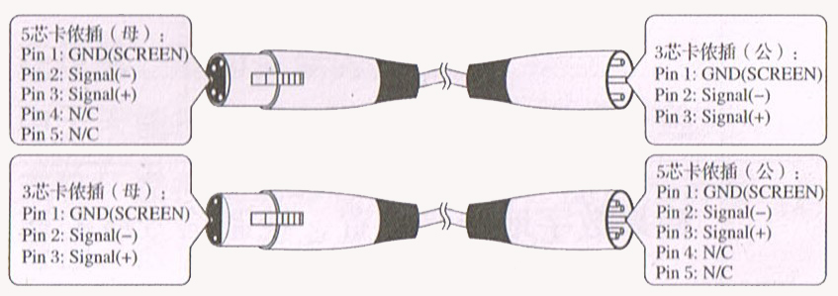
3-Pins connection
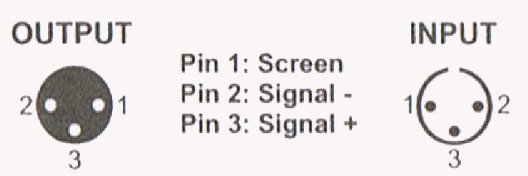
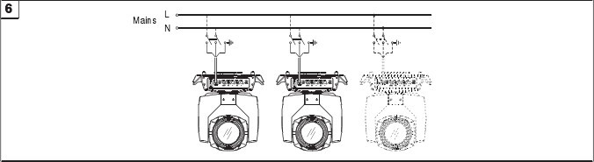
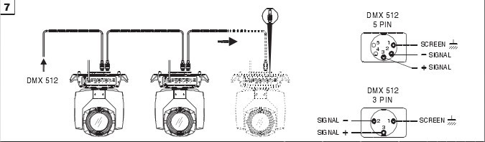

Cleaning and maintenance

Cleaning should be performed every 15-day period, by using a sponge which is dipped with alcohol, rather than wet cloth or other chemical liquid, to clean the mirror.

Cut off power before cleaning and maintenance!
CAUTION

Attention

Do not see directly light source when open the light, and make sure power off before do any installation or maintenance.


 Wires connection must be done professional person!
CAUTION

Cautions
Before delivery, this device has passed strict inspection, Please follow the user manual strictly for operation, if this fixture is damaged by improper operation and mistake, the fixture will be out of warranty, and manufacture or dealer won’t be responsible for it. In case of any technology change in this manual,we won’t advise in further .

Common issues instruction

Issues | Solve instruction
No power | Check power’s voltage
When power in, output light but the device cannot accept control signal | Check address setting and the control DMX cable connection well or not
The effect have light shadow | Check electronic focus DMX channel value, if it’s suitable distance
Light beam dim | The lamp maybe arrived end of using life, should change new lamp, and also check light source cleaning or not
Note: the maintenance should be done by the verified technician.

Warranty Card
This product is made of high-brightness transistor. We will provide 1 year warranty under the condition that user has operated the light normally and lifetime service. We won't provide warranty if the damage is caused by artificial or force majeure event. Cost of fittings should be charged by user if product need maintenance after 1 year .Please cut this warranty card and shipped it along with the product to our factory when applying for warranty.
Product：
Purchasing date：
Code of invoice：
Warranty date: From To
User’s name： Add：
Company： Tel：

